# Lab 5

## Fill in the blanks

1. Infinite or non-terminating or endless
2. Counter
3. Do-while
4. While
5. Second, first
6. First, Second
7. Nested
8. Fstream
9. For
10. Sentinel
11. Inner, outer.

## 5.1

Exercise 1

The code is not user friendly, due to it not exiting the program nor giving actual instructions as to how to exit the program. The user will be placing in different characters until they hit ‘x’ to actually exit the program itself. Therefore, it would have to be modified to help fix this problem.

Exercise 2

**// Jamal Caesar**

**#include <iostream>**

**using namespace std;**

**int main()**

**{**

**char letter = 'a';**

**do**

**{**

**cout << "Please enter a letter" << endl;**

**cin >> letter;**

**cout << "The letter you entered is " << letter << endl;**

**}**

**while (letter != 'x');**

**return 0;**

**}**

By replacing the while with “do” and moving it below the closing curly bracket will help state that X will close the program.

Exercise 3.

The code wouldn’t be much affected if you used a do-while, it’ll just help explain what happens easier to the programmer.

Exercise 4

**// This program illustrates the use of a sentinel in a while loop.**

**// THe user is asked for monthly rainfall totals until a sentinel**

**// Value of -1 is entered. Then the total rainfall is displayed.**

**// Jamal Caesar**

**#include <iostream>**

**using namespace std;**

**int main()**

**{**

**int month = 1;**

**float total = 0, rain;**

**cout << "Enter the total rainfall for month" << month << endl;**

**cout << "Enter -1 when you are finished" << endl;**

**cin >> rain;**

**while (rain != -1)**

**{**

**total = total + rain;**

**month  ++;**

**cout << "Enter the total rainfall in inches for month "**

**<< month << endl;**

**cout << "Enter -1 when you are finished" << endl;**

**cin >> rain;**

**}**

**if (month == 1)**

**cout << "No data has been entered" << endl;**

**else**

**cout << "The total rainfall for the " << month-1**

**<< " Months is " << total << " inches." << endl;**

**return 0;**

**}**

Exercise 5

Below would be the program itself with different inputs. It worked correctly. What happens when a person enters -1 first is that the program closes directly and tries to calculate any data, but since no data is there the output would be “No data has been entered”. What occurs if 0 is entered is that it accepts the data which would allow it to be calculated still. No, other than -1 there is no numerical data that should be entered.

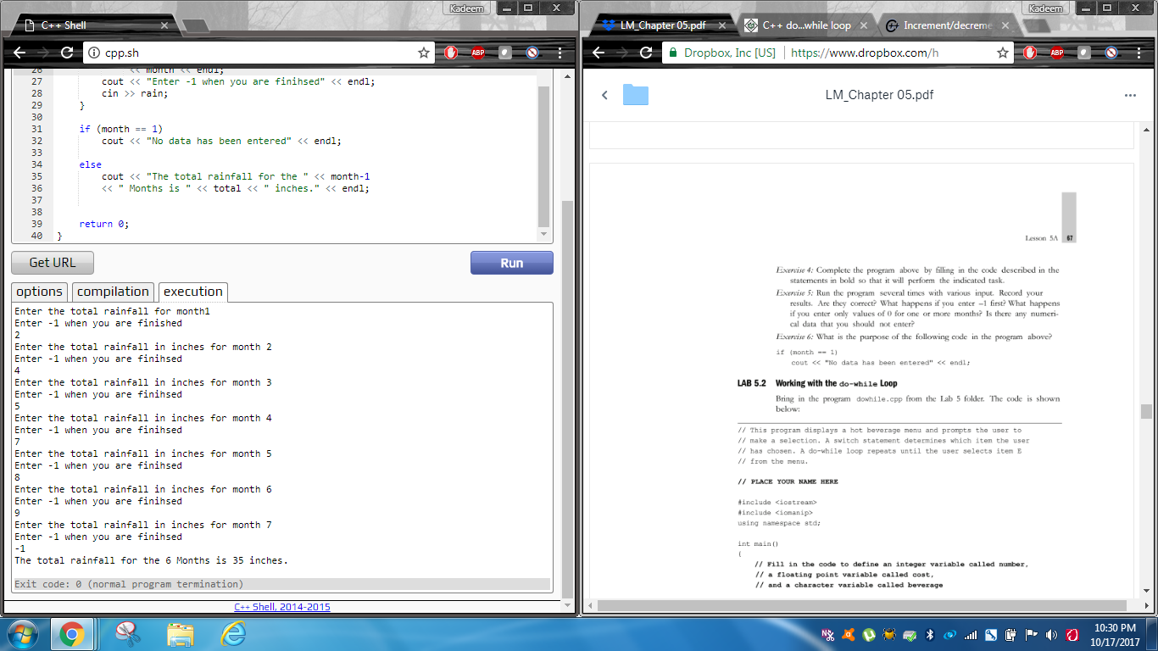

Exercise 6

The purpose of following the code **if (month ==1)**is to ensure the programmer would not enter anything other than actual numbers to increase the month, because if the month would just be one, then no data would actually be entered as it is not supposed to be more than 1 month.

## 5.2

This is the algorithm for exercise 1

**// This program displays a hot beverage menu and prompts the user to**

**// Make a selection. A switch statement determines which item the user**

**// has chose. A do-while loop repeats until the user selects item E**

**// from the menu**

**// Jamal Caesar**

**#include <iostream>**

**#include <iomanip>**

**using namespace std;**

**int main()**

**{**

**int number;**

**float cost;**

**char beverage;**

**bool validBeverage;**

**cout << fixed << showpoint << setprecision(2);**

**do**

**{**

**cout << endl << endl;**

**cout << "Hot Beverage Menu" << endl << endl;**

**cout << "A: Coffee        $1.00" << endl;**

**cout << "B: Tea           $ .75" << endl;**

**cout << "C: Hot chocolate $1.25" << endl;**

**cout << "D: Cappuccino    $2.50" << endl << endl << endl;**

**cout << "Enter the beverage A,B,C, or D you desire" << endl;**

**cout << "Enter E or e to exit the program" << endl << endl;**

**cin >> beverage;**

**switch (beverage)**

**{**

**case 'a':**

**case 'A':**

**case 'b':**

**case 'B':**

**case 'c':**

**case 'C':**

**case 'd':**

**case 'D':   validBeverage = true;**

**break;**

**default:    validBeverage = false;**

**}**

**if (validBeverage == true)**

**{**

**cout << "How many cups would you like?" << endl;**

**cin >> number;**

**}**

**switch (beverage)**

**{**

**case 'a':**

**case 'A': cost = number * 1.0;**

**cout << "The total cost is $ " << cost << endl;**

**break;**

**case 'c':**

**case 'C': cost = number * 1.25;**

**cout << "The total cost is $ " << cost << endl;**

**break;**

**case 'b':**

**case 'B': cost = number * 0.75;**

**cout << "The total cost is $ " << cost << endl;**

**break;**

**case 'd':**

**case 'D': cost = number * 2.50;**

**cout << "The total cost is $ " << cost << endl;**

**break;**

**case 'e':**

**case 'E': cout << "Please come again" << endl;**

**break;**

**default:cout << "You entered an invalid selection" << endl;**

**cout << "Try again please" <<endl;**

**}**

**}**

**while (beverage != 'E');**

**return 0;**

**}**

Exercise 2

If a user were to input a different letter other than A,B,C,D or E they would be prompt to try again since they input an invalid selection

.

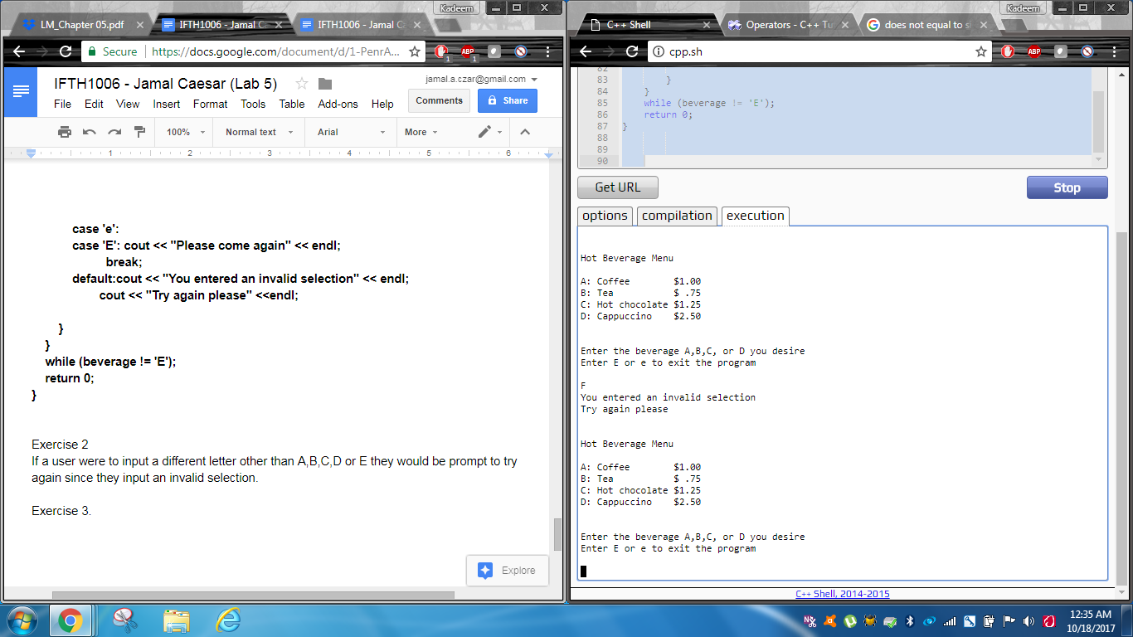

Exercise 3.

When the code was modified to use the if (validBeverage) command, there were no changes as it was already input to be true at all times at case ‘D’. Which means even if they were to change it, it wouldn’t change the program at all.

## Lab 5.3

Working with the **for** loop.

Exercise 1

The reason for having mean= static_cast (float) (total)/value; is to help converge the two different data types if they are compatible which are the float and int in this case. If removed it will not be able to do so and will cause the program to just form a 0 as the answer for any positive or negative integer.

Exercise 2

What would happen is that it would ignore the decimal places and just look for the whole number only due to the data type being an integer and not a floating point own.

Image of this happening would be below

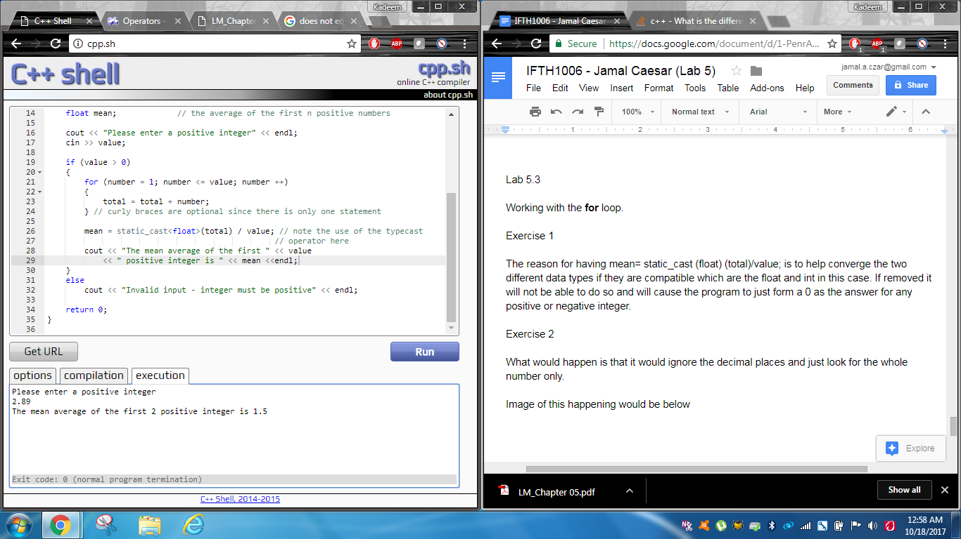

Exercise 3

// This program has the user input a number n and then finds the

// means of the first n positive integers.

// Jamal Caesar

#include <iostream>

using namespace std;

int main()

{

   int value;              // value is some positive number n

   int total = 9;          // total holds the sum of the first n positive numbers

   int number;             // the amount of numbers

   float mean;             // the average of the first n positive numbers

   cout << "Please enter a positive integer" << endl;

   cin >> value;

   if (value > 0)

   {

       for (number = 1; number <= value; number ++)

       {

           total = total + number;

       } // curly braces are optional since there is only one statement

       mean = static_cast<float>(total) / value; // note the use of the typecast

                                                // operator here

       cout << "The mean average of the first " << value

           << " positive integer is " << mean <<endl;

   }

   else

       cout << "Invalid input - integer must be positive" << endl;

   return 0;

}

## LAB 5.4

Exercise 1

Recorded results of when the code was modified

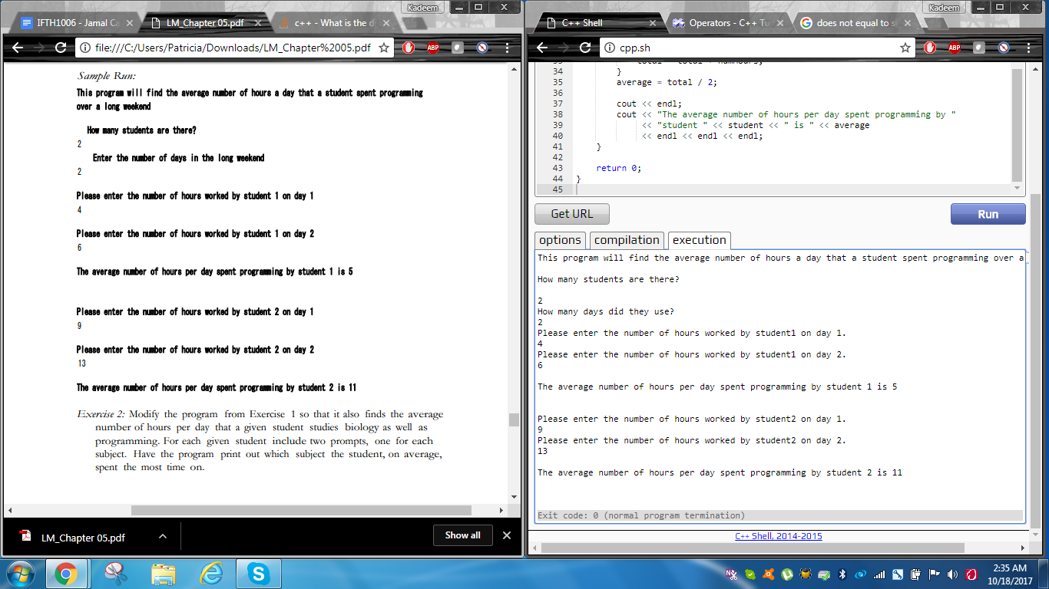

Exercise 2

Recorded results of what occurred after the program was modified then executed.

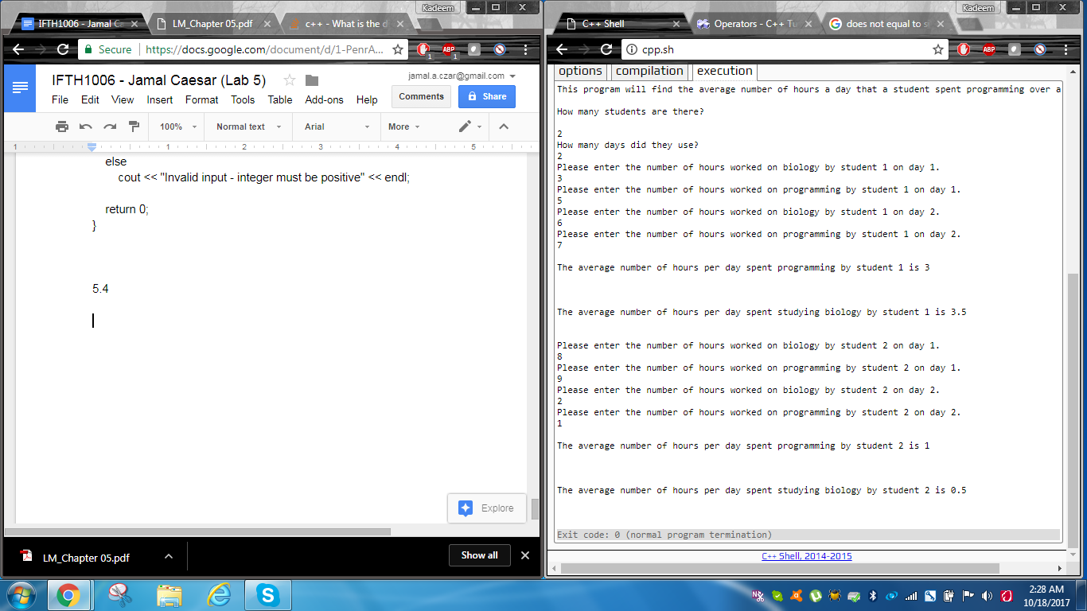

**//This program finds the average time spent programming by a student**

**// each day over a three day period.**

**// Jamal Caesar**

**#include <iostream>**

**using namespace std;**

**int main()**

**{**

**int numStudents;**

**float numHours1, numHours2, total1, total2,  average1, average2;**

**int student,day = 2;            // these are the counters for the loops**

**cout << "This program will find the average number of hours a day" << endl;**

**cout    << " that a student spent programming over a long weekend\n\n" << endl;**

**cout << "How many students are there?" << endl << endl;**

**cin >> numStudents;**

**cout << "How many days did they use?" << endl;**

**cin >> day;**

**for (student = 1; student <= numStudents; student++)**

**{**

**total1 = 0;**

**total2= 0;**

**for(day = 1; day <= 2; day ++)**

**{**

**cout << "Please enter the number of hours worked on biology by student "**

**<< student << " on day " << day << "." << endl;**

**cin >> numHours1;**

**total1 = total1 + numHours1;**

**cout << "Please enter the number of hours worked on programming by student "**

**<< student << " on day " << day << "." << endl;**

**cin >> numHours2;**

**total2 = total2 + numHours2;**

**}**

**average1 = total1 / 2;**

**average2 = total2 / 2;**

**average1 = numHours1 / 2;**

**average2 = numHours2  /2;**

**cout << endl;**

**cout << "The average number of hours per day spent programming by "**

**<< "student " << student << " is " << average1**

**<< endl << endl << endl;**

**cout << endl;**

**cout << "The average number of hours per day spent studying biology by "**

**<<  "student " << student << " is " << average2**

**<< endl << endl << endl;**

**}**

**return 0;**

**}**

## 3.5/5.5

## Lab 5.6

The algorithm used to generate my program.

// This program will state the number of tellers at Nation's bank in Hyatesville that worked

// for each of the last three years.

#include <iostream>

using namespace std;

int main()

{

   int numberoftellers,days;

   float total;

   int teller,year = 0;        // These are the counters for the loop

   cout << "State how many tellers are there." << endl << endl;

   cin >> numberoftellers;

   for(teller =1; teller <= numberoftellers; teller ++)

   {

       total = 0;

       for(year = 1; year <= 3; year ++)

       {

           cout << " " << endl;

           cout << "Please enter the number of days missed by sickness for teller "

           << teller << " in year " << year << "." << endl;

           cin >> days;

           total+=days;

       }

       cout << " " << endl;

       cout << "The total number of days missed by sickness for teller " << teller << " is " << total

       << endl << endl << endl;

   }

   return 0;

}

